
FOR IMMEDIATE POSTING

CONTACT
Laurie L
Chair, Public Information
publicinformation@oamilwaukee.org

Overeaters Anonymous Virtual Convention

Milwaukee, Wis. – March 31, 2021 – The Milwaukee Area Intergroup of Overeaters Anonymous (OA MAI) announces its 40th Annual Convention on April 16-18, 2021; the convention will be Virtual.

The theme of the 2021 convention is as follows:
HOPE SPRINGS ETERNAL
Finding Joy in Recovery
WALK INs are Welcome…follow link at oamilwaukee.org starting April 16

The OA MAI Convention opens on Friday, April 16 from 6:00–9:00 pm. It continues Saturday, April 17 from 8:00 am–8:30 pm. The Convention closes on Sunday, April 18 from 9:00 am to Noon. All times are Central Daylight Time.
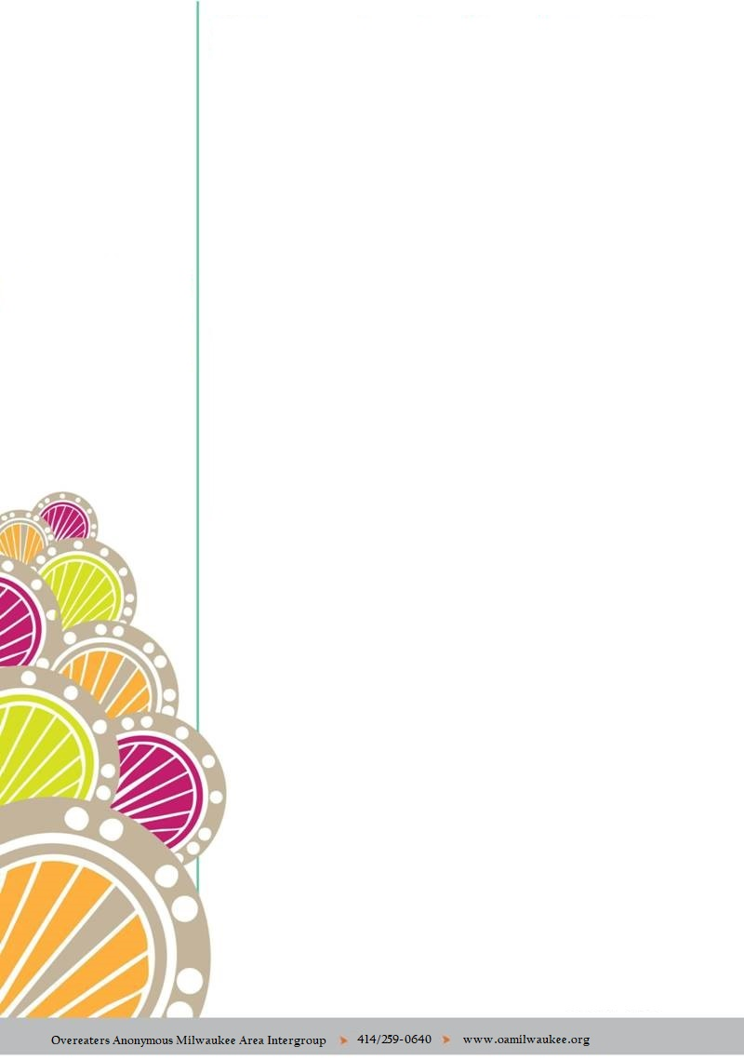
Two tracks of programming and a virtual Hospitality Center will be open throughout the Convention weekend except during the five Keynote speakers.
MAI is offering a Virtual Pre-Convention Workshop on Friday, April 16 from 1:00–4:00 pm. The Workshop is titled Step into the Sunlight of the Spirit: Hope in the Spiritual Solution. Members may attend the Pre-Convention Workshop only. Speakers will share the experience, strength and hope of their personal journeys. Participants will have opportunities to write, meditate and share about their own pathway to HP.
Registration is available by phone, by mail or online (small surcharges apply online.)
Please check our website at www.oamilwaukee.org for more Convention and registration information.
# # #

About the Milwaukee Area Intergroup:
The Milwaukee Area Intergroup of Overeaters Anonymous serves members who reside in the eastern half of Wisconsin including the Milwaukee Metropolitan Area, areas south to the state border and areas north to Green Bay and beyond. For more information, please visit www.OAMilwaukee.org, email info@OAMilwaukee.org or call 414/259-0640.

